大数据的心理与健康
主讲人简介
1.上海交通大学, 汪小帆教授

汪小帆教授，上海交通大学致远学院常务副院长，长江学者特聘教授、国家杰出青年科学基金获得者。长期从事复杂网络理论与应用研究，曾获IEEE电路与系统汇刊最佳论文奖、上海市自然科学一等奖和自然科学牡丹奖、上海市领军人才、国家级教学成果一等奖和国家自然科学二等奖，入选人事部“新世纪百千万人才工程国家队人选”，享受政府特殊津贴。现为国际自动控制联合会（IFAC）复杂大系统技术委员会主席、全国复杂网络与系统控制专委会主任。

2. 微软亚洲研究院, 谢幸 研究员/博导
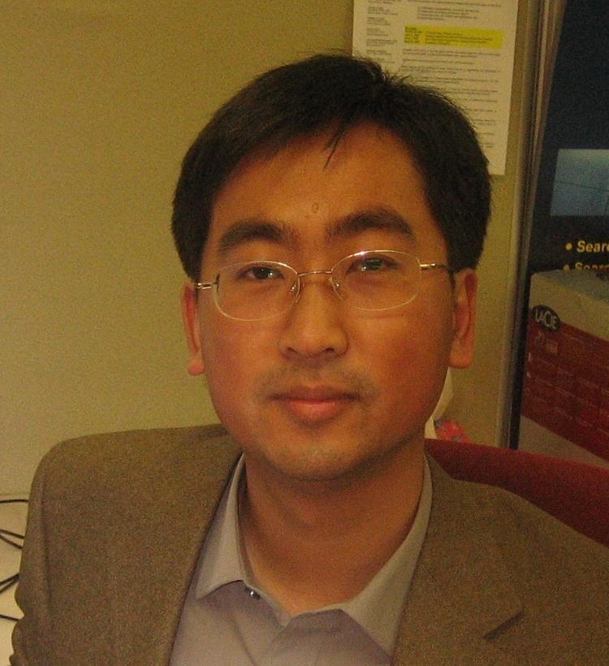
Dr. Xing Xie is currently a senior researcher in Microsoft Research Asia, and a guest Ph.D. advisor for the University of Science and Technology of China. He received his B.S. and Ph.D. degrees in Computer Science from the University of Science and Technology of China in 1996 and 2001, respectively. He joined Microsoft Research Asia in July 2001, working on spatial data mining, location based services, social networks and ubiquitous computing. During the past years, he has published over 160 referred journal and conference papers. He has more than 50 patents filed or granted. He has been invited to give keynote speeches at SocInfo 2015, Socialinformatics 2015, GbR 2015, W2GIS 2011, HotDB 2012, SRSM 2012, etc.
He currently serves on the editorial boards of ACM Transactions on Intelligent Systems and Technology (TIST), Springer GeoInformatica, Elsevier Pervasive and Mobile Computing, Journal of Location Based Services, and Communications of the China Computer Federation (CCCF). In recent years, he was involved in the program or organizing committees of over 70 conferences and workshops. Especially, he initiated the LBSN workshop series and served as program co-chair of ACM UbiComp 2011, the 8th Chinese Pervasive Computing Conference (PCC 2012) and the 12th International Conference on Ubiquitous Intelligence and Computing (UIC 2015). In Oct. 2009, he founded the SIGSPATIAL China chapter which was the first regional chapter of ACM SIGSPATIAL. He is a member of Joint Steering Committee of the UbiComp and Pervasive Conference Series. He is a senior member of ACM and the IEEE, and a distinguished member of China Computer Federation (CCF).

3.南开大学，陈浩副教授

陈浩，南开大学社会心理学系副教授，近年来一直致力于心理信息学的研究探索，在《Journal of Personality》、《Personal Relationships》、《心理学报》、《系统科学与数学》等学术期刊以及SMC’15、BESC’15等IEEE学术会议上，发表40余篇中英文论文。曾参与或主持973项目课题、国家自然科学基金重点和一般项目，国家社会科学基金重大、重点、一般项目等多项课题。曾荣获亚洲社会心理学会第二届青年学者奖(2009)、全国优秀博士学位论文提名奖(2010)、BESC 2015最佳论文奖(2015)。
陈浩现为《Asian Journal of Social Psychology》,《心理学报》,《Journal of Systems Science and Complexity》,《心理科学进展》, 《情报杂志》等学术期刊审稿人。并任天津市社会心理学会理事，中国社会心理学会青年工作委员会委员，南开大学创业研究中心、南开大学商学院网络社会治理研究中心兼职研究员。

4. 四川师范大学， 徐华春博士
徐华春，四川师范大学教育与心理学院硕士生导师，长期从事人格与社会心理学、心理健康领域研究，在《中国临床心理学杂志》、《心理科学》、《心理科学进展》等杂志发表多篇学术论文。

5. 微软亚洲研究院， 袁晶研究员
Dr. Nicholas (Jing) Yuan is currently a researcher in Microsoft Research Asia. He got a Ph.D degree in Computer Science from the School of Computer Science and Technology in 2012, and a B.S. degree in Mathematics from the School of the Gifted Young in 2007, both in University of Science and Technology of China. From 2009 to 2012, He worked as a full time research intern in MSR Asia. Currently, his research interests include user modeling, behavioral data mining, spatial-temporal data mining and computational social science. He is a Microsoft Fellow, a member of CCF (China Computer Federation), ACM, and IEEE.

During the past few years, Nicholas has published more than 40 papers in top-tier conferences and journals, including ACM SIGKDD, IEEE TKDE, ACM Ubicomp, ICDE, WWW, AAAI, etc. His work has been featured by influential media such as MIT Technology Review many times. He served as program chair of HuMoComp 2013-2015, industry chair of ASONAM 2016, area chair of NLPCC 2016, and regularly as program committee members in top conferences such as SIGKDD, WWW, ACL, AAAI, IJCAI, ICDM, WSDM, ICWSM, and SDM.

Nicholas has been honored with Microsoft Fellowship (2011), Best Paper Award of IEEE International Conference on Data Mining (2013), Best Paper Runner-up Award of ACM SIGSPATIAL (2010), Distinguished Doctoral Dissertation Award of Chinese Academy of Sciences (2013), and Outstanding Graduates of Anhui Province (2012).

6.南开大学， 王琰博士

王琰博士，南开大学周恩来政府管理学院社会学系讲师，2008年毕业于南开大学社会学系，2010年和2013年获美国爱荷华大学硕士和博士学位。长期致力于全球环境下的环境治理方面的研究，在《International Journal of Public Opinion Research》、《社会学评论》、《International Review for the Sociology of Sport》、《Nonprofit and Voluntary Sector Quarterly》等期刊发表多篇论文。

